YOUR HEALTH NEWS  THE RIDGEWAY SURGERY AND  RIDGEWAY SURGERY PATIENT PARTICIPATION GROUP NEWSLETTER  Summer Edition 2026 | 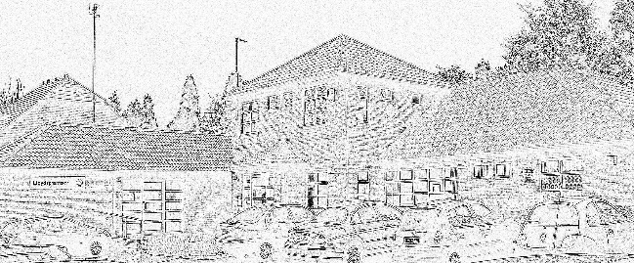

*** Welcome to the latest edition of The Ridgeway Surgery Newsletter ***
(If you need this Newsletter in LARGER PRINT or an ALTERNATIVE LANGUAGE, please advise Reception).
A copy of this Newsletter will appear on the surgery website : www.ridgewaysurgery.co.uk.

Keep your details updated - There are feedback forms on the Website and in Reception. Do keep Reception updated with any changes to your contact details.

News Items
The planned Ridgeway Surgery Coffee Morning fund raiser for Dementia and MND (Motor Neurone Disease) in aid of the Alzheimer’s Society and MND Association will take place at the Northway precinct, Sedgley DY3 3QY on Thursday 2nd July 2026 from 11 a.m. till 1 p.m. It is supported by The Cosey Bean and The Cabin.
There will be assisting stalls, including The Myaware charity, who support and raise awareness of the Myasthenias, a group of neuromuscular conditions.

Please do drop in and support this event
.

RSV Vaccination
We’re pleased to inform we are contacting patients who are eligible for the RSV Vaccination to make appointments to have this vaccination

Shingles Vaccination
As with the RSV Vaccinations we are also contacting patients who are eligible for the Shingles vaccination to come to the surgery for this vaccination

HPV Vaccination
Any patients who may have missed this vaccination while at school can contact the surgery and arrange this vaccination

Spring Covid Vaccination Clinics
After a successful covid vaccination campaign, we have now finished giving these vaccinations at the surgery for this spring. If you have not had your vaccination, please contact your local pharmacy who can provide this service.

Dudley Borough GP Practice Charter.
This is a set of “protocols” for the Surgeries and Patients and what you can expect from your surgery:
https://www.ridgewaysurgery.co.uk/you-and-your-general-practice
Guest Speakers at the recent PPG meeting.
Catherine from Unheard Voices, the SEND carers support group gave a very illuminating and passionate talk on the practicalities and current situations for children either in in schools or being home tutored who have special needs. There is a drop in session for interested people on Fridays (10.30 till noon) at Jubilee Hall, Ladies Walk, Sedgley DY3 3UA. She is also involved in a radio show.
Catherine can be contacted by email on unheardvoices13@yahoo.com or phone 07739 534702.
Pharmacist Havan Howrami from “The Chemist next door to our Surgery!” updated us on the positive way the Pharmacy is running and what it offers. Further NHS updates to what Pharmacists will be able to offer by the end of the year will be communicated back to us. _ _ _
Please note that we help produce a “parallel” newsletter representing the PCN (Primary Care Network) of a group of our local surgeries. Recent speakers at the meetings included topics on Mental Health and Domestic Abuse and a report on these will feature in the next PCN newsletter which is usually made available on the Surgery websites.

Thank you for reading this newsletter.

